**Deploying Docker Container using Base Python3 Linux Image**

**Process:**

**Set Up AWS Resources**

Logged in to AWS Management Console.  
• Launched EC2 Instance: (virtual machine - Ubuntu).

And security groups to allowed SSH (port 22) traffic with instance type - T2.medium and 20Gb disk size and created PPK file.

**Connect to Your EC2 Instance**

•    Used SSH to connect to EC2 instance using the PPK file via Putty as below.

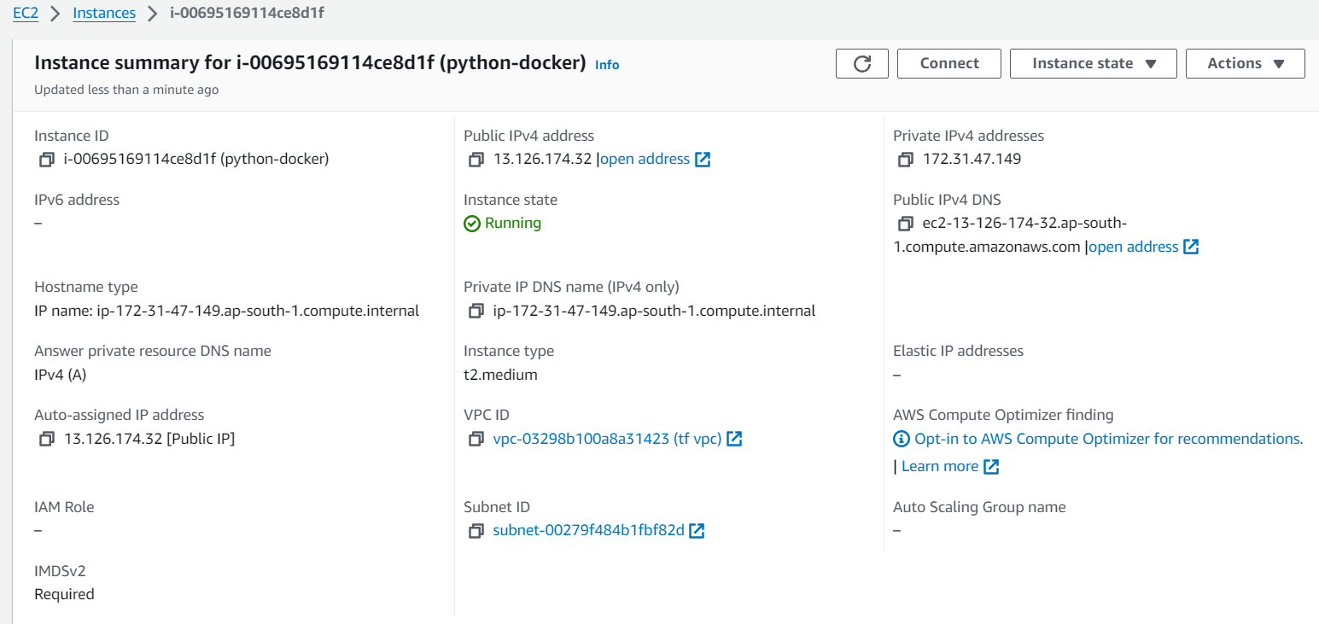

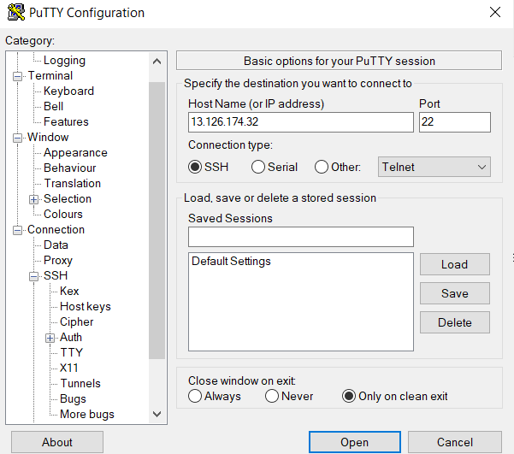

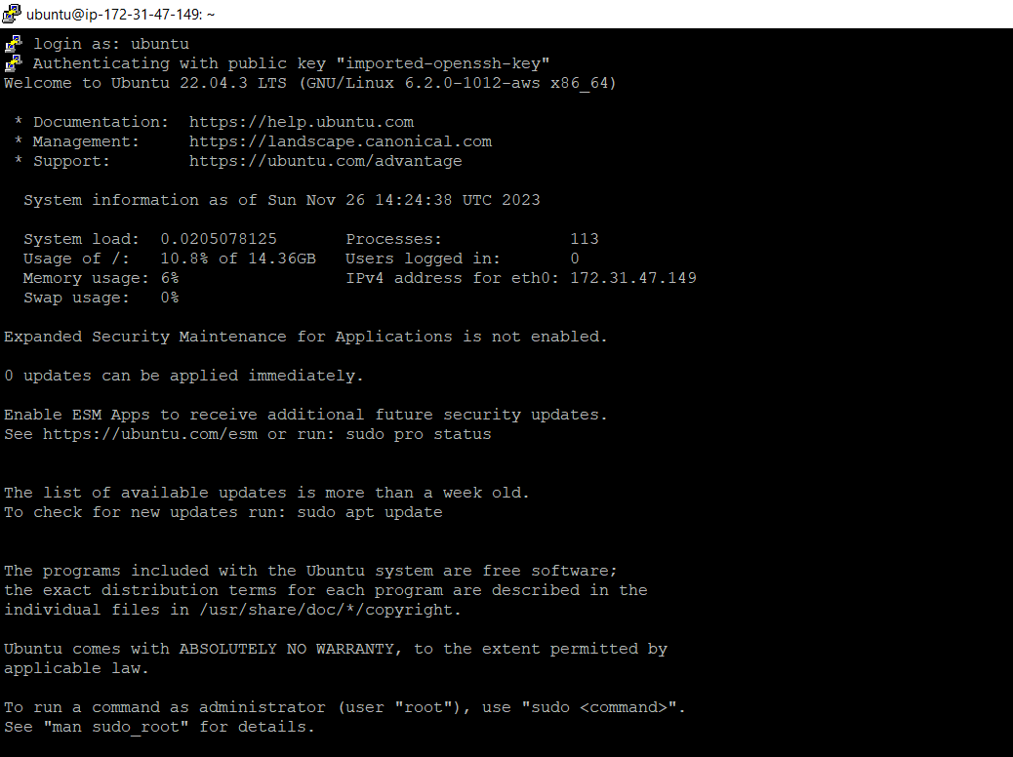

**Install docker on to the machine for creating and running docker container:**

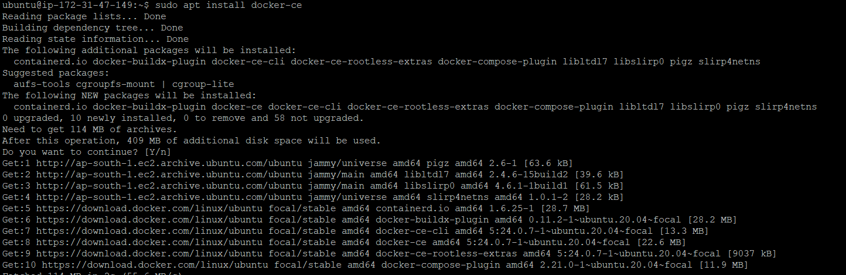

**Install python on to the machine:**

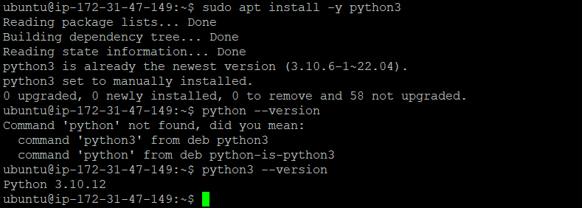

**Created a new project application.py (Basic addition calculator) in**

**/home/ubuntu directory**

**Vim application.py**

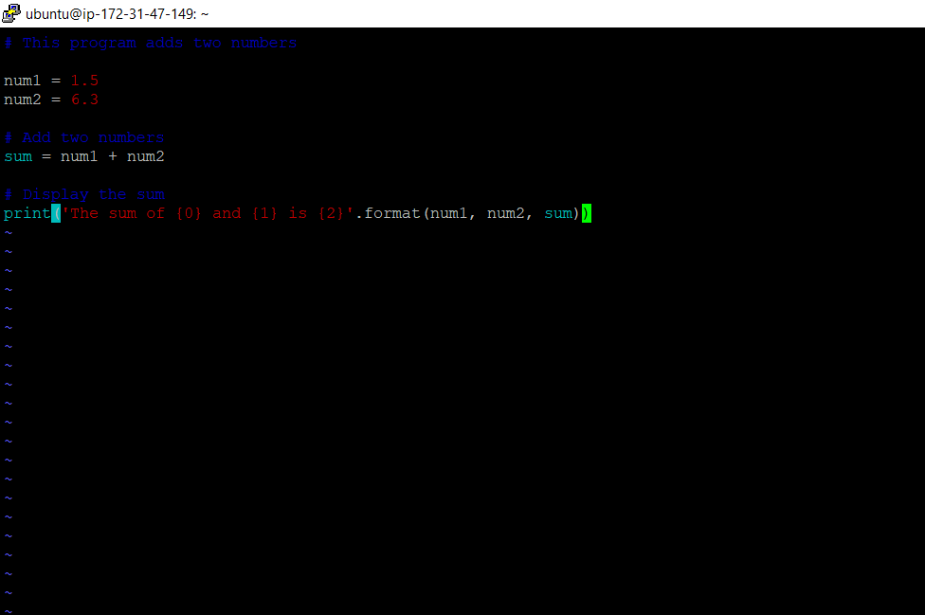

**Created a file named Dockerfile in the /home/ubuntu directory. This file defined the steps to built the Docker image as below:**

**In the Dockerfile, used the FROM instruction to specify the base image as python:3.**

**Copied application code into the Docker container using the COPY instruction in the Dockerfile.**

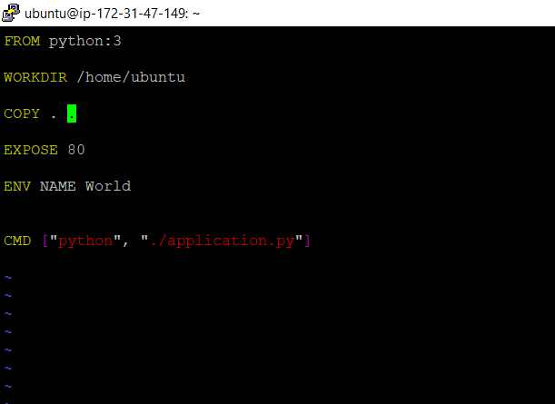

**Built up the Docker file using the docker build command. Provide a suitable tag name for the image.**

**Sudo docker build -t my-python-app .**

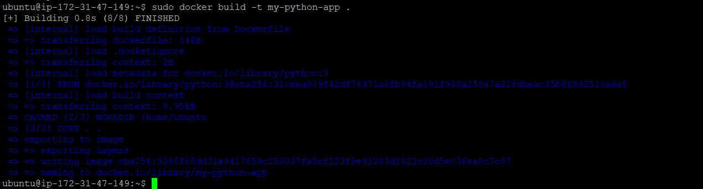

**After successfully built the docker file we got the docker image as below:**

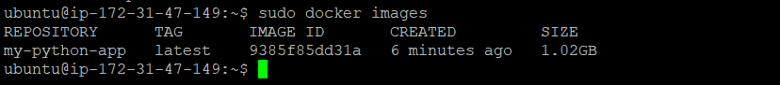

**Added port entry to the SG as below port 80 and 4000 :**

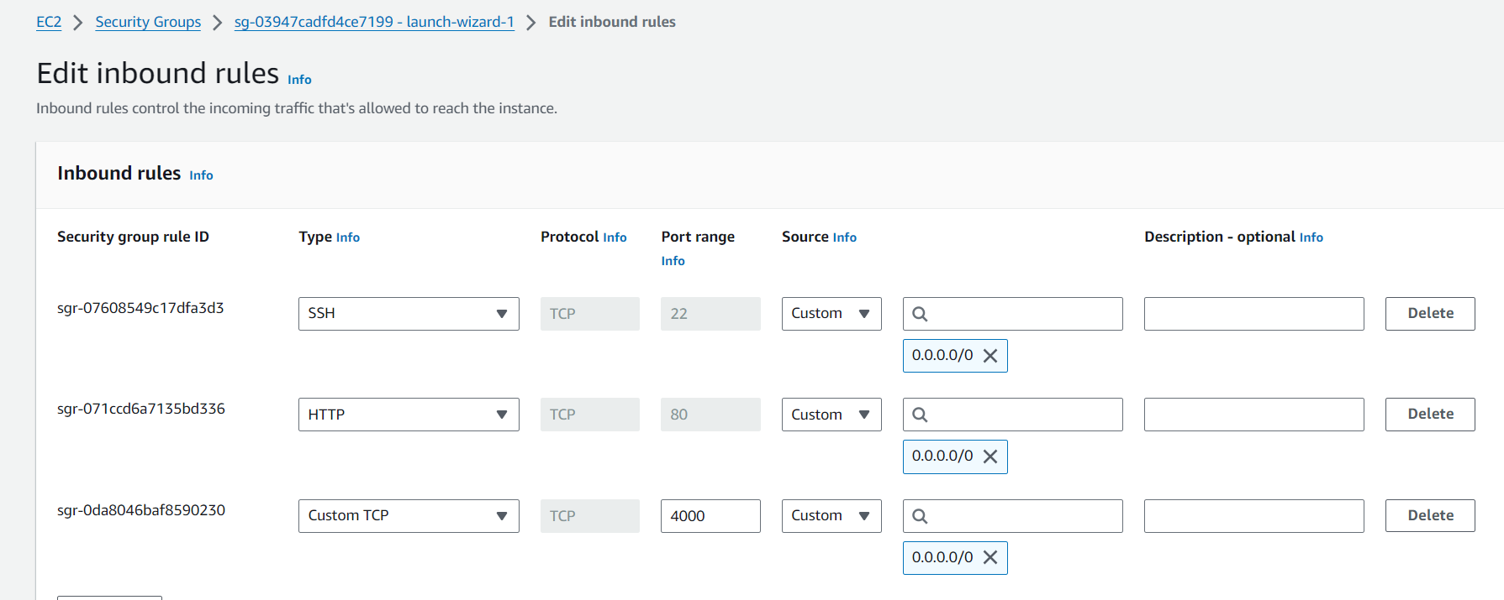

**Ran the Docker container based on the created image using the docker run command as below:**



**And we got successful result as addition of Two numbers.**

**Python code:**

**Application.py**

**# This program adds two numbers**

**num1 = 1.5**

**num2 = 6.3**

**# Add two numbers**

**sum = num1 + num2**

**# Display the sum**

**print('The sum of {0} and {1} is {2}'.format(num1, num2, sum))**